HANOI UNIVERSITY
FACULTY OF INFORMATION TECHNOLOGY



ADVANCED TOPIC IN INFORMATION TECHNOLOGY
FINAL REPORT
HEALTHCARE DIABETES RISK PREDICTION

Course: Advanced Topic in IT
Class: ATI-CLC 02
Instructor: PhD. Nguyen Xuan Thang
Group 16: 2201140003 - Khuc Ngoc Anhs
2201140048 - Le Thi Khanh Linh
2201140064 - Tran Thanh Phuc

December 22th, 2025

TABLE OF CONTENTS
1. Introduction 3
2. Dataset Overview and Experimental Setup 3
2.1. Dataset 3
2.2. Distribution of Key Health Indicators 4
2.3. Correlation Analysis of Features 6
3. Performance Analysis of the MLP Model 7
3.1. Overall Performance of the MLP Model 7
3.2. Confusion Matrix Analysis 7
3.3. ROC Curve Analysis 8
3.4. Threshold Tuning Analysis 9
4. Comparison with Baseline Models 10
4.1. Overall Performance Comparison 10
4.2. Class-wise Performance Comparison 11
4.3. Discussion on Model Suitability for Healthcare 11
5. Discussion and Limitations 11
6. Conclusion and Future Directions 12

LIST OF FIGURES
Figure 1: Target Distribution: Diabetes Binary..............................................................................4
Figure 2: Distribution of BMI.........................................................................................................4
Figure 3: Distribution of Age..........................................................................................................5
Figure 4: Distribution of GenHlth...................................................................................................5
Figure 5: Correlation Matrix of Numeric Features.........................................................................6
Figure 6: Confusion Matrix - Binary MLP.....................................................................................7
Figure 7: ROC Curve of Binary Diabetes Risk...............................................................................8
Figure 8: Precision-Recall vs Threshold Curve..............................................................................8

1. Introduction
Diabetes is one of the most prevalent chronic diseases and poses a significant burden on healthcare systems worldwide. Early prediction of diabetes risk plays a crucial role in prevention and timely intervention. With the rapid development of machine learning and deep learning techniques, leveraging large-scale health data has become an effective approach to addressing this problem.
This report analyzes the experimental results of Logistic Regression, Random Forest, and Multilayer Perceptron (MLP) models for diabetes risk prediction. Among these, the MLP is treated as the primary model to assess its ability to capture nonlinear relationships within the data, while the other two models serve as baseline methods for comparison. The main focus of this report is on interpreting model prediction behavior and evaluating the suitability of these approaches in the context of real-world healthcare data.

2. Dataset Overview and Experimental Setup

2.1. Dataset
The dataset consists of 269,131 samples with 21 input features and one target variable indicating diabetes status. The features cover several important categories, including cardiovascular conditions (HighBP, HighChol), lifestyle behaviors (Smoker, PhysActivity), body-related indicators (BMI), general and mental health status (GenHlth, MentHlth, PhysHlth), as well as demographic factors such as age, sex, education level, and income. The inclusion of diverse feature groups enables the models to capture health-related information in a comprehensive manner.
Analysis of the label distribution reveals a class imbalance, with the non-diabetic group accounting for approximately 72.22% of the total samples. The data are split into a training set of 215,304 samples and a test set of 53,827 samples, ensuring sufficient scale to evaluate the generalization performance of the models in a realistic healthcare setting.
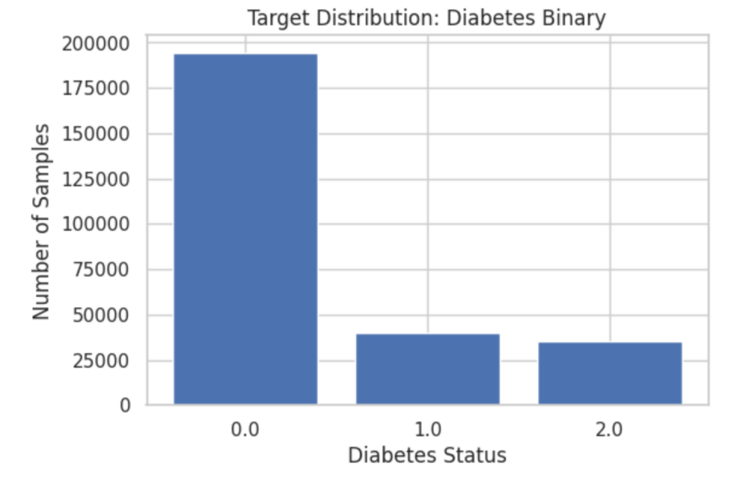
Figure 1: Target Distribution: Diabetes Binary

2.2. Distribution of Key Health Indicators
The BMI distribution is clearly right-skewed, with most samples concentrated between 20 and 35 and a peak at average to slightly elevated values, indicating a large proportion of overweight individuals. The presence of higher BMI values reflects substantial variance, consistent with real-world health data, and may affect the decision boundaries learned by deep learning models.
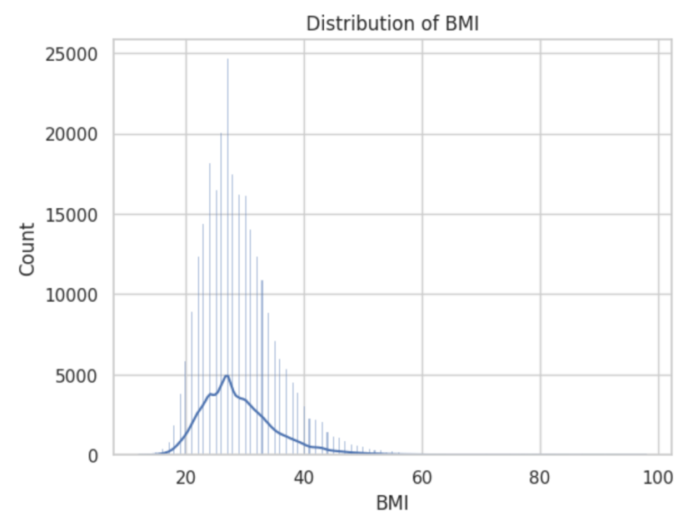
Figure 2: Distribution of BMI
Age is distributed in discrete groups, with sample counts increasing in middle-aged and older categories. The highest frequencies occur in groups 8–11, indicating a large proportion of individuals with higher age-related diabetes risk, consistent with epidemiological patterns and highlighting age as a key predictive factor.
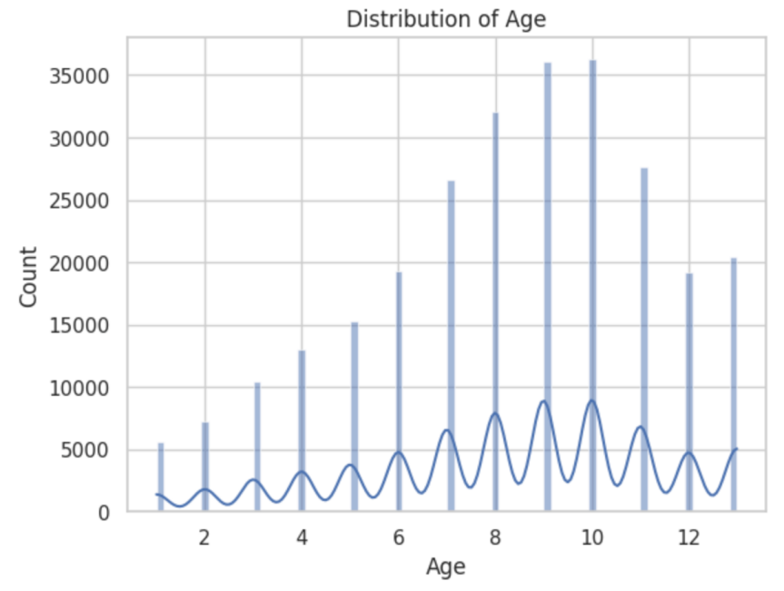
Figure 3: Distribution of Age
The GenHlth distribution is concentrated at levels 2 and 3, indicating generally good to moderate health, while poorer health levels (4 and 5) occur less frequently but remain substantial. This reflects diverse baseline health conditions and suggests that GenHlth serves as a composite indicator of overall diabetes risk.
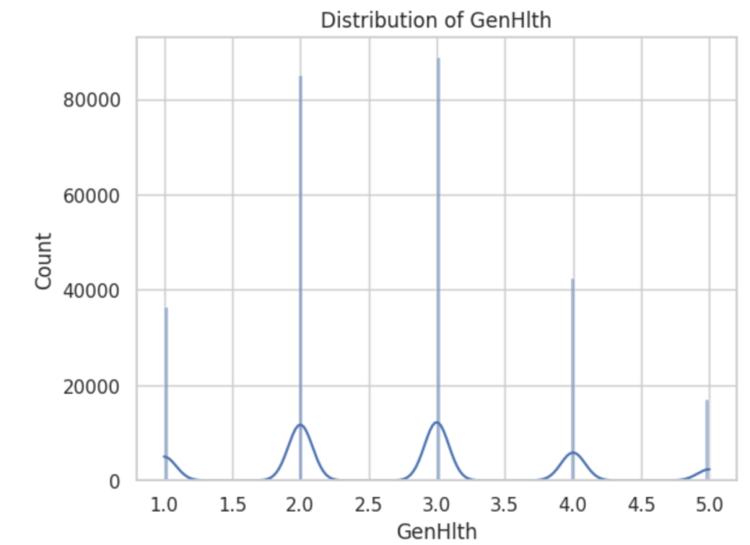
Figure 4: Distribution of GenHlth
Overall, the distributions of BMI, Age, and GenHlth reflect realistic healthcare patterns and show substantial overlap across value groups, indicating that diabetes risk prediction requires the combination of multiple features rather than reliance on a single factor, which aligns well with the MLP approach used in this study.

2.3. Correlation Analysis of Features
The correlation matrix shows mostly low to moderate feature correlations, indicating no severe multicollinearity. Diabetes_binary is weakly positively correlated with health-related variables (HighBP, BMI, HeartDiseaseorAttack, DiffWalk) and weakly negatively correlated with lifestyle and socioeconomic factors (PhysActivity, Education, Income). Strong correlations among GenHlth, MentHlth, and PhysHlth reflect the close link between physical and mental health, supporting the suitability of MLP for modeling complex nonlinear relationships.
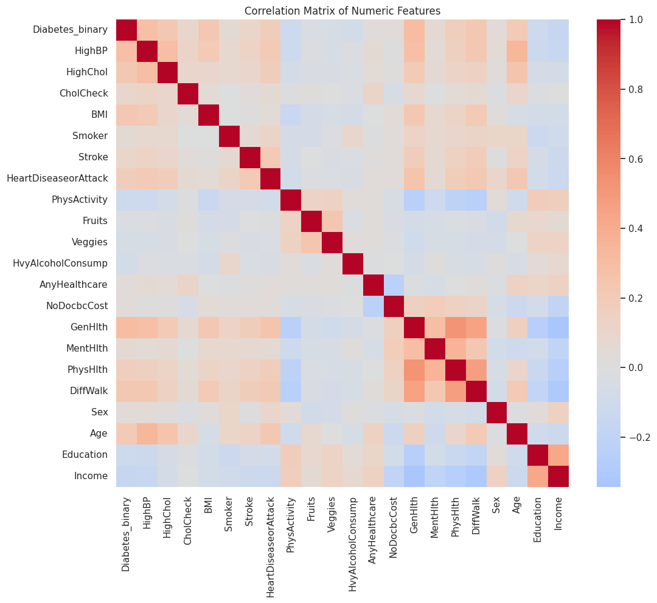
Figure 5: Correlation Matrix of Numeric Features

3. Performance Analysis of the MLP Model

3.1. Overall Performance of the MLP Model
In the binary classification setting, the MLP model achieves similar accuracy on the training (71.56%) and test (71.78%) sets, indicating stable generalization without severe overfitting. Given the large and imbalanced healthcare dataset, this suggests that the chosen MLP architecture is appropriate. However, accuracy alone is insufficient for diabetes risk prediction under class imbalance, making class-specific metrics and prediction behavior analysis necessary.

3.2. Confusion Matrix Analysis
The confusion matrix indicates that the MLP effectively identifies diabetic cases, correctly predicting 9,791 positives while missing 5,160, resulting in high recall for the diabetic class. However, the model also produces a relatively high number of false positives (7,902), reducing precision. This trade-off is acceptable in medical screening contexts, where missing at-risk patients is more critical than generating additional follow-up examinations.
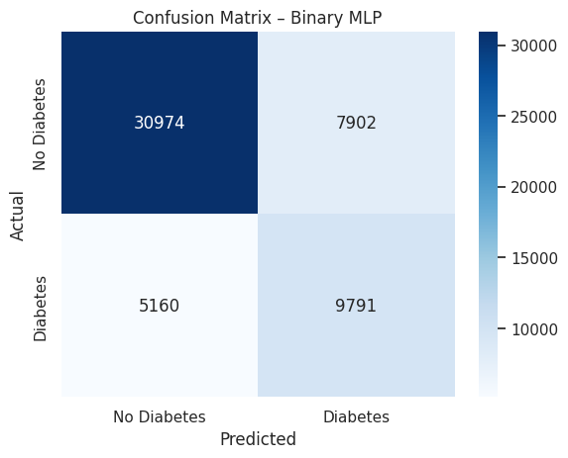
Figure 6: Confusion Matrix - Binary MLP

3.3. ROC Curve Analysis
The ROC curve of the MLP model demonstrates a strong ability to distinguish between diabetic and non-diabetic classes. The area under the curve (AUC) reaches 0.818, indicating that the model learns discriminative features effectively and performs substantially better than random guessing.
Furthermore, the ROC curve remains well above the diagonal reference line across most classification thresholds, suggesting stable performance under varying decision thresholds. This property is particularly important in healthcare applications, where threshold adjustment may be required to balance sensitivity and specificity according to different screening objectives.
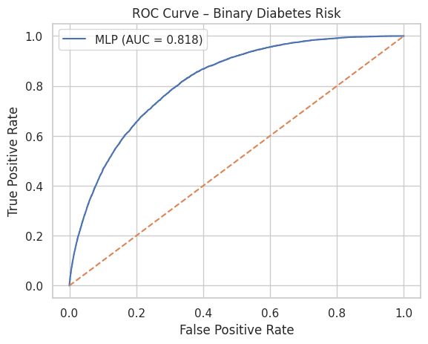
Figure 7: ROC Curve of Binary Diabetes Risk

3.4. Threshold Tuning Analysis
The relationship between precision, recall, and the decision threshold shows a clear trade-off: increasing the threshold improves precision but reduces recall, while lower thresholds increase recall at the cost of more false positives. The optimal threshold is approximately 0.51, yielding the highest F1-score and a balanced precision–recall trade-off. This threshold tuning, rather than using the default 0.5, reflects a practical deployment-oriented approach suitable for medical screening applications with varying priorities.
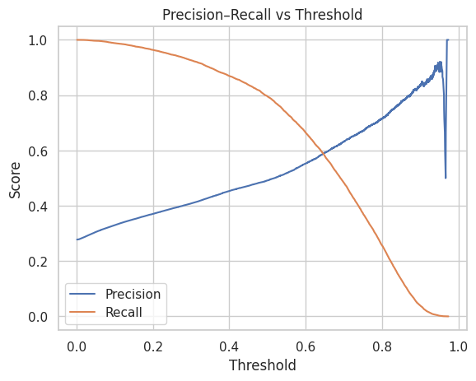
Figure 8: Precision-Recall vs Threshold Curve
Overall, the MLP model demonstrates stable generalization, high recall for diabetic cases, and flexible threshold adjustment, making it suitable for early diabetes risk detection; however, the relatively high false positive rate indicates the need for further improvement before real-world deployment.

4. Comparison with Baseline Models

4.1. Overall Performance Comparison
Random Forest achieves the highest accuracy (78%), followed by MLP (73%) and Logistic Regression (72%). However, under class imbalance, accuracy does not necessarily reflect clinical usefulness. In terms of weighted F1-score, Random Forest performs best (76%), followed by MLP (74%) and Logistic Regression (74%). This indicates that while baseline models optimize performance on the majority class, they may vary in their effectiveness for detecting diabetic cases.

4.2. Class-wise Performance Comparison
Class-wise analysis reveals that Random Forest performs extremely well on the non-diabetic class, achieving a recall of 92% and an F1-score of 86%. However, it struggles to identify diabetic cases, with a recall of only 41%, indicating a bias toward the majority class. Logistic Regression shows a better balance for the diabetic class with a recall of 75% and an F1-score of 60%.
In contrast, the MLP model demonstrates the highest ability to identify diabetic cases. Although its overall accuracy is not the highest, the MLP achieves the best recall for the diabetic class (77%) and the highest F1-score (61%), making it more valuable in medical risk prediction scenarios. The confusion matrix confirms this strength, showing 9,791 correct positive predictions.

4.3. Discussion on Model Suitability for Healthcare
Overall, no single model achieves optimal performance across all evaluation metrics. Random Forest obtains the highest accuracy but offers limited clinical value due to its lower recall (41%) in detecting diabetic patients. The MLP model, while slightly inferior in overall accuracy, provides the best balance between disease detection and generalization performance.
From a healthcare perspective, the MLP is a more suitable choice for diabetes risk screening systems, where minimizing missed diagnoses is a primary concern. Nevertheless, the results indicate that further improvements are necessary to reduce the 7,902 false positives and enhance real-world applicability.

5. Discussion and Limitations
The experimental results indicate that the MLP model demonstrates a strong ability to identify individuals at risk of diabetes, as evidenced by its high recall in the binary classification setting. In healthcare applications, reducing missed diagnoses is often more critical than maximizing overall accuracy, and the model’s relatively high false positive rate reflects a safety-oriented prediction strategy suitable for early screening rather than clinical diagnosis. In addition, threshold tuning allows the model to flexibly adapt to different medical objectives and operating conditions.
However, several limitations remain. The dataset exhibits significant class imbalance, which adversely affects performance, particularly in the multiclass classification setting. Moreover, the MLP model does not incorporate advanced imbalance-handling techniques and lacks interpretability, both of which are essential for trust and adoption in real-world medical systems. Overall, these findings highlight that accuracy alone is insufficient for evaluating imbalanced healthcare problems, and that comprehensive analysis using confusion matrices, ROC curves, and threshold adjustment is necessary to understand model behavior and support effective deployment.

6. Conclusion and Future Directions
This study evaluates machine learning and deep learning models for diabetes risk prediction using large-scale health data and shows that the MLP achieves stable performance with clear advantages in binary classification, particularly in identifying high-risk individuals. Its high AUC and strong recall for the diabetic class highlight its potential for medical screening where early detection is prioritized over overall accuracy. However, performance remains affected by data imbalance, and future work should focus on imbalance handling, loss optimization, and model interpretability to improve reliability for real-world healthcare deployment.

